PERSONAL PROFILE

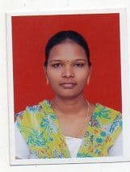
Name: Y.B.L. RUPA
Designation: Guest Faculty in Commerce
College Address: SRR & CVR GDC (A) Vijayawada
Cell No: 9052284653
Mail Id: rupa.yindukuri@gmail.com

Educational Qualifications
S.NO | COURSE | BOARD / UNIVERSITY | YEAR OF PASS | PERCENTAGE
1 | Master in Commerce | Krishna University | 2012 | 64
2 | Bachelor in Commerce | Acharya Nagarjuna University | 2010 | 52.3
3 | Intermediate | Board of Intermediate | 2007 | 62.7
4 | Secondary School | Board of Secondary School | 2005 | 55

Professional Experience:
- Worked as Guest Faculty in commerce in GDC(W), Guntur from 2015 to 2018
Achievements: NIL
Memberships: NIL
In service programs attended: NIL
Research Experience : Article published: NIL
Conferences at International level: NIL
Conferences at National level: NIL
Conferences at State Level: NIL
Workshops attended: NIL
Administrative Experience NIL

